Ang Mo Kio - Thye Hua Kwan Hospital – Grizzly Badgers IS480

**Discussion Notes**

Date: 30 Sep 2016

Start Time: 1405H

End Time: 1500H

**In-Attendance (AMK-THKH)**

Mr Edy Chandra (MIS)

**In-Attendance (SMU / Grizzly Badgers [GB])**

Abdul Shahid

Christopher Teo

**Agenda**

1. Determine hardware available for usage
2. Proposed solutions and considerations
3. Determine functions and features
4. UAT locations
5. Possibility of studying other organisations’ processes and allowing other VWOs to use the solution

|  |  |
| --- | --- |
| **Minutes of Meeting** | **Action By** |
| * 1. Hardware available for usage   THKH has laptops, printers, barcode scanners available for “Triage System”. Tablets are also available, although not used for “Triage System”.  Should the GB team require other hardware such as tablets or mobile devices, they will need to request for it in advance. |  |
| * 1. Proposed solutions and considerations   Team GB proposed 3 possible solutions of varying costs. Refer to **Annex A**.  These solutions are based on the considerations, referred to in **Annex B**.  All 3 solutions are similar in terms of providing self-registration to a visitor. This a web-based form which visitors are able to provide the required details (personal particulars, purpose of visit, visit location, screening questions & declarations) even before entering the hospital.  Upon entering the hospital, the visitor will need to have his temperature taken and recorded in the system. He will not be allowed if his temperature is above the specified value, if he is not ‘cleared’ by the screening questions, or if the maximum number of visitors for the patient is reached.  Low-cost implementation  A pass is given or printed which the visitor will have to display prominently. He will have to scan his pass at the entrance.  Access to the visitor will be provided when the nurses verify his pass and confirm that he is entering an area he is allowed to.  Upon exit, the visitor will have to scan out.  If the pass is not disposable, the visitor will have to return it.  Medium-cost implementation  The visitor will collect a pass / QR code / barcode / RFID card. If the visitor registered online, the QR code / barcode can be provided to him on his mobile device upon self-registration.  He will scan it upon entry and upon passing by different ‘checkpoints’ of the hospital such as the entrance to a ward or wing. Each ‘checkpoint’ is equipped with a computer and a scanner, or a mobile device.  Upon exit, the visitor will have to scan out.  If the pass is not disposable or belongs to the hospital, the visitor will have to return it.  High-cost implementation  The visitor will collect RFID card / beacon.  He will carry it with him throughout his visit. The receivers installed at different ‘checkpoints’ will pick up the visitor’s movements in the hospital.  Upon exit, the visitor will return the beacon.  Points to note and Remarks   * Although the visitor registers online, some verification has to be done to ensure the accuracy of data.   + For example, the visitor will have to upload a picture of his NRIC for verification of his personal particulars.   + The nurse should also confirm his health by visual inspection and double check on the screening questions in the web form. * The GB team is looking toward facilitating the temperature taking process. * Edy to check with Sarah of temperature taking and keying in of temperature must be manual as a form of verification. * Edy showed concern on enforcement of returning of passes and beacons. * There is a favour toward the medium-cost implementation solution. This is dependent on THKH management’s decision. GB Team is to submit a proposal to Edy by 17 Oct. Proposal to include how the solution can reduce manual processes and cost. Also to include a cost breakdown. * GB Team is to consider backup solutions for the system in case of failure. Traces of the low-cost implementation solution might need to exist. * Passes can be differentiated according to design, not necessarily colour. | Edy  Chris |
| * 1. Determine functions and features   GB Team will determine the list of functions and features.  They will have to ensure the following conditions are met   * Flexibility to set parameters at UI level (eg maximum of 5 visitors per patient, logo changes) * Easy configurations at UI level |  |
| * 1. UAT locations   THKH expressed possibility of conducting UAT in the hospital. GB Team will need to provide advance notice.  THKH will need to seek approval and advice from Dr Jocelyn | Edy |
| 1. Possibility of studying other organisations’ processes and allowing other VWOs to use the solution   GB Team will like to check on the possibility to study other institutions’ processes within and outside the Thye Hua Kwan group.  The team will also like to check if there is a possibility of allowing other non-profit institutions adopt their solution after the solution has been developed. | Edy |

Notes taken by:

Christopher Teo

**Annex A – Three solutions of according to implementation costs**

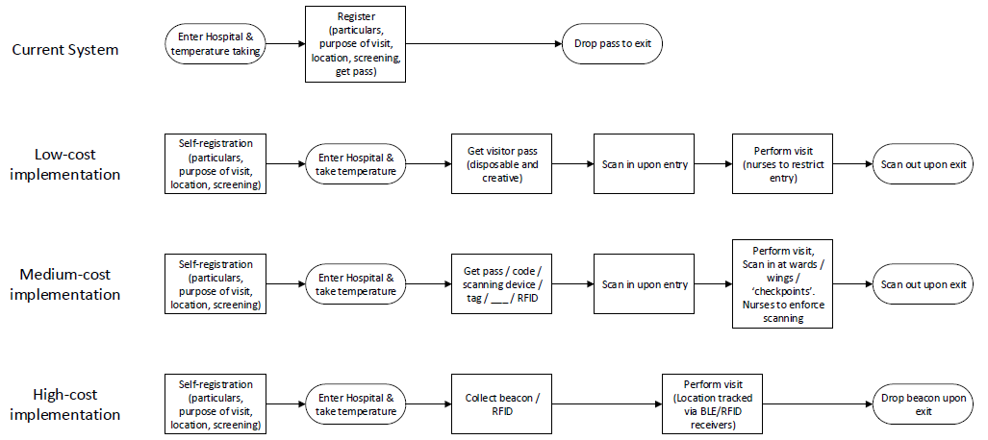

**Annex B – Considerations for solutions**

